**WAGNER—**Letter L – 2 bar rest

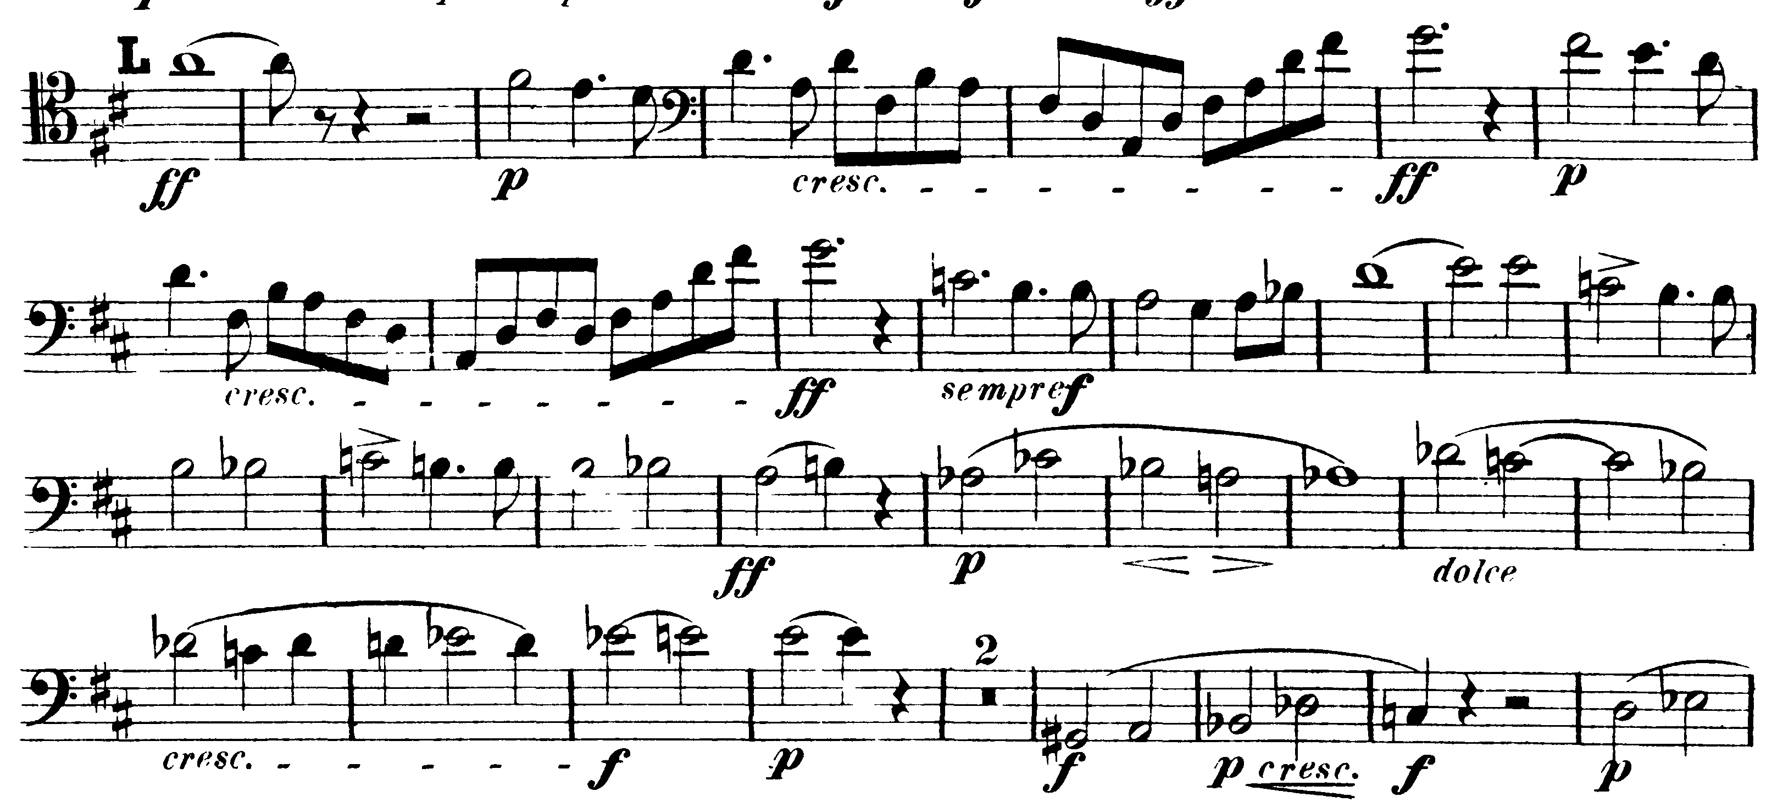

**TCHAIKOVSKY—**Mvt I: Q – 332

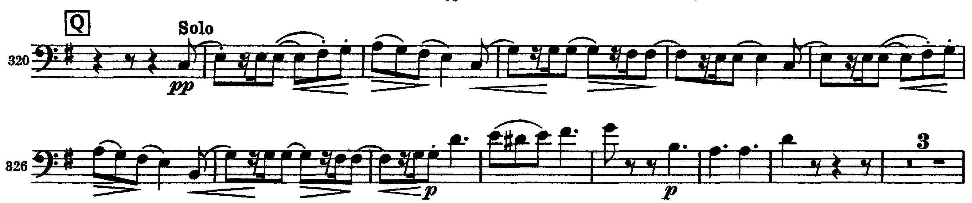

Mvt II: 71 – 74 & E – 86

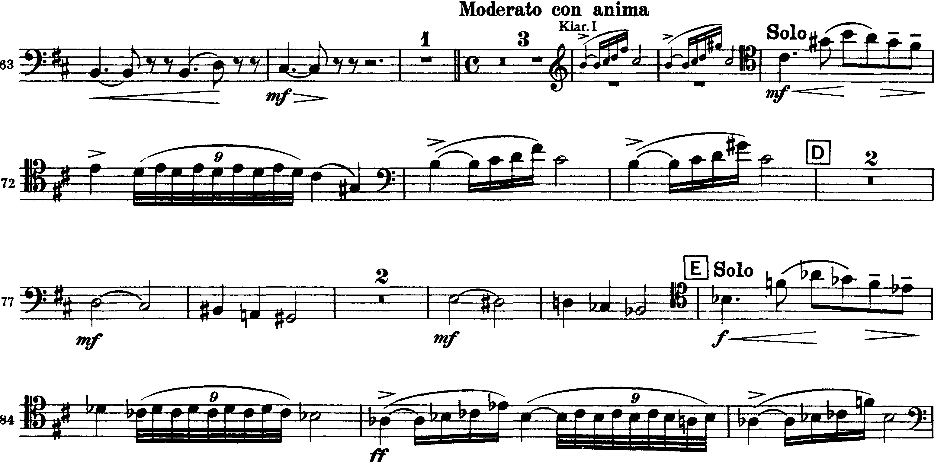

Mvt III: pick-up to 57 – 72 (Allegro moderato valse)

